Project Report 

|  |  |
| --- | --- |
| **Product Name** | Applied Degree in Software Engineering (BDSE) |
| **Qualification Name** | Applied Degree in Software Engineering |
| **Product Name** | Programming Foundations |
| **Module Name (BDSE)** | **Programming Foundations** |

|  |  |  |  |  |
| --- | --- | --- | --- | --- |
| Learner name | | | Assessor name | |
| Agung Yuda Pratama | | |  | |
| **Date issued** | **Completion date** | | | **Submitted on** |
|  |  | | |  |
|  | | | | |
| **Project title** | | **Development of MCQ System** | | |

### Plagiarism

Plagiarism covers both copying or paraphrasing with the source without proper understanding and citation. The source includes but is not limited to

* Books, Journal Articles, Online resources
* Others Assignment or project
* Software program
* Images

The learners must submit their work without plagiarism while producing the evidence against the assessment criteria. They must apply proper citation and Harvard referencing. Their work must go through the Turnitin software to check for the similarity index. Please consult the relevant module instructor or mentor if you need any further advice.

|  |
| --- |
| **Learner declaration** |
| I certify that the work submitted for this assignment is my own and research sources are fully acknowledged.  Student signature: Date:23-11-2022 |
|  |

Lithan | EDU Class © 2022

Table of Contents

1. Introduction

2. Background

3. Task 1:

Briefly describe what an algorithm is and design an algorithm to process the form inputs and outputs of the process in the project scenario.

4. Task 2:

Explain briefly Procedural, Object Oriented and Event driven paradigms, Give example of programming language which will be used to implement each of them.

What programming paradigms you use for this project ?

Document the architecture of the System along with Module and its Components description.

5. Task 3:

Provide the source code of implementation for the algorithm written in Task 1.

Provide a brief note on how the algorithm is translated to equivalent code.

6. Task 4:

Briefly explain how you have used object oriented features to build the application.

Provide sample source code and explain how you have used object oriented features to create a particular functionality.

7. Task 5:

List and briefly explain the steps you will follow from writing code to execution.

8. Task 6:

Explain briefly 5 features which are available in IntelliJ or Eclipse, which you use to build this application.

9. Task 7:

Explain briefly how using an IDE is better than not using an IDE.

10. Task 8:

Explain briefly how using an IDE is better than not using an IDE............................

11. Task 9:

Explain briefly the steps involved in debugging and how does it helps to develop more secure and robust applications......................................................................

12. Task 10:

List Coding standards you have using in the development of the application and explain 5 of them briefly with its importance...........................................................

### Development of MCQ System

# Introduction

# The Writer Summative Assessment for the "Applied Degree in Software Engineering" Course's "Foundations of Programming" Module. The Writer will use Java to design, implement, and test an MCQ system for this project. The Writer has the chance to showcase writer abilities in the following areas through this project:

# 1. Capable of creating Java command-line apps.

# 2. Outline the web application programming process and define the fundamental algorithms for database operations.

# 3. Prove your programming expertise in procedural, object-oriented, and event-driven design.

# 4. Developing the application with, IntelliJ, or Eclipse.

# 5. Describe the debugging process and discuss the significance of coding standards.

# 6. Construct technical documentation and run unit tests.

# Background

# Scenario

# The Writer is working as an intern for a significant education industry leader. The Writer currently works on a team that develops software to evaluate subject expertise. The following situations are provided, and the company is required to submit the MCQ system:

# 1. The system must handle multiple sets of multiple-choice questions. For instance, Basic HTML, Control Structures, and Java.

# 2. The system will display questions from the selected list when you choose a set.

# 3. Allow people to respond, and score them depending on their responses. For instance, if a user correctly answers 8 out of 10 questions, they should receive a score of 80%.

# As a member of the research and development team, The Writer's responsibilities include looking into new procedures that might be advantageous to the business. The Writer was requested to conduct research to identify an appropriate algorithm.

# Task 1

#### An algorithm is a limited number of discrete, step-by-step instructions to solve a problem. In programming activities, an algorithm is typically viewed as a logic to decide the program to be made. However, another definition of an algorithm is a path utilized in a calculation or systematically addressing a problem.

#### 

* **MCQ System Development Pseudo Code:**

1. “User can input their name using the Scanner”

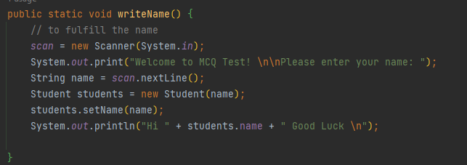

1. “User can choose the test according to the MCQ set that given”

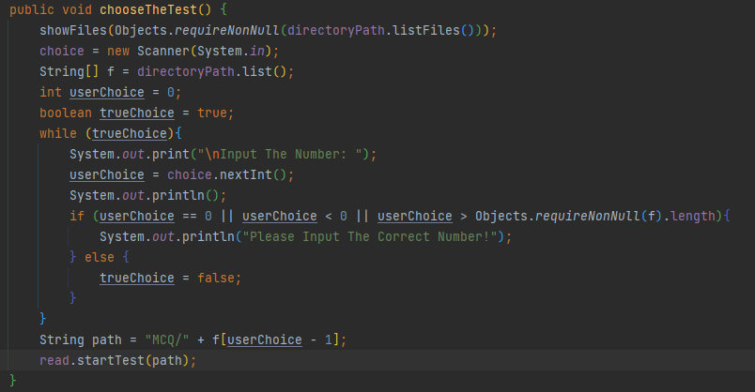

1. “System reading the file using BufferedReader”



1. “System will read the file and show the test and option”

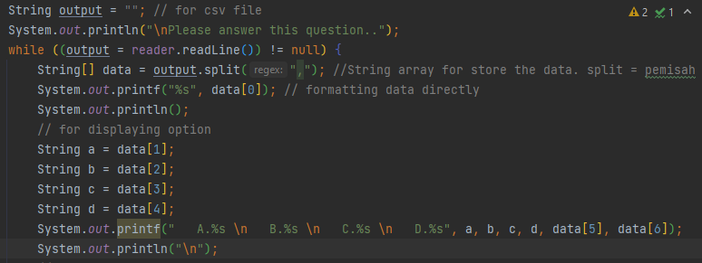

1. and validation for input ABCD

boolean optionTest = true;  
String getAnswer = null;  
while (optionTest){  
 Scanner answer = new Scanner(System.*in*);  
 // for displaying answer  
 System.*out*.print("Your answer: ");  
 getAnswer = answer.nextLine();  
 if (Objects.*equals*(getAnswer, "a") || Objects.*equals*(getAnswer, "b") || Objects.*equals*(getAnswer, "c") || Objects.*equals*(getAnswer, "d")){  
 optionTest = false;  
 } else {  
 System.*out*.println("\nYou can only input A,B,C,D\n");  
 }  
}

1. The System Will calculate the correct and wrong answer an

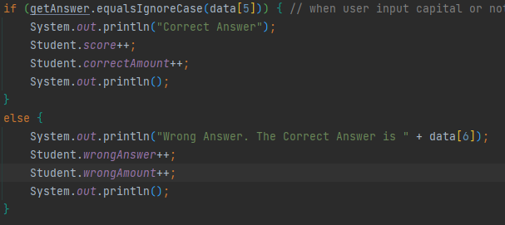

1. showResult “mean the score will appear”

private static void showResult() {  
 int finalScore = Student.*getScore*();  
 String name = *s*.name;  
 System.*out*.println("Name: " + name + "\nYou answered "+ Student.*correctAmount* + " Questions Right, " + Student.*wrongAmount* + " Question Wrong for a total of 10 Questions " + "\nScore: " + finalScore +"0%");  
 System.*out*.println("\nThank you for attending The Test \nHave a nice day ");  
}

# Task 2

# Object Oriented Programming Paradigm

#### According to Gillis and Lewis, Object-oriented programming or OOP is defined as object-oriented programming which is a computer programming model with software design settings around data or objects. Unlike another programming that focuses on function and logic, OOP focuses more on objects or data fields that have unique technical attributes or behaviors. OOP's focus on objects allows for developer manipulation and lends itself well to large, complex programming. This OOP approach is easier when it comes to updates and maintenance.

#### Object-oriented programming (OOP) is a programming paradigm based on the concept of "objects", which can contain data and code: data in the form of fields (often known as attributes or properties), and code, in the form of procedures. (Nythar, 2022)

#### OOP can be used in various programming languages such as JavaScript, C++, Java, and Python. The use of this class in OOP programming can determine what attributes an object instance will have, such as color and so on. OOP is becoming more concise because developers can focus more on manipulating objects than logic or functions.

# Procedural (Imperative) Paradigm

# The Procedural Paradigm, also known as the imperative paradigm, uses a programming method by issuing commands to be executed by the computer. Line by line is executed sequentially from top to bottom, where all data and code are combined into one part in one program.

**Event Driven Programming Paradigm**

Event-driven programming is a programming paradigm in which the flow of the program is determined by events such as user actions (mouse clicks, key presses), sensor outputs, or messages passing from other programs or threads. Event-driven programming is the dominant paradigm used in graphical user interfaces, and other applications (e.g., JavaScript web applications) centered on performing certain actions in response to user input. Event-driven programming is also true of programming for device drivers.

**Example of Programming Language Which Will Be Used in The Implementation and The Programming Paradigm**

# The Writer will be used Java Language Program to design The MCQ Test.

# 

# The Programming Paradigm that will be used by the author is :

# Object Oriented Program (OOP)

# Because the writer produced an object with a state that can only be changed by built-in procedures—in this case, a Student class—the writer employed the object-oriented programming paradigm.

1. The Functional Programming paradigm

# The Writer has been using the functional programming paradigm because The Writer created a calculation that calculates the results of a test that students/examinees will take.

# Task 3

#### MCQ Test Development Algorithm :

1. The program starts.
2. Ask the name of the student.
3. Get access to the CSV file using java.
4. Reading files using java.
5. Let student choose what MCQ Test they want.
6. Display questions to students.
7. Asking for input as answers from students for each question.
8. Calculate the score based on the correct answers from students.
9. Displays the names and grades of students.

|  |  |
| --- | --- |
| Note | Screen Capture |
| Start The Program |  |
| Asking student’s name |  |
| Get access to the csv file using java. |  |
| Reading files using java & display questions to students |  |
| Asking for input as answers from students for each question. |  |
| Calculate the score based on the correct and wrong answers from students. |  |
| Displays the names and grades of students. | private static void showResult() {  int finalScore = Student.*getScore*();  String name = *s*.name;  System.*out*.println("Name: " + name + "\nYou answered "+ Student.*correctAmount* + " Questions Right, " + Student.*wrongAmount* + " Question Wrong for a total of 10 Questions " + "\nScore: " + finalScore +"0%");  System.*out*.println("\nThank you for attending The Test \nHave a nice day "); }  } |

# Task 4

The OOP concept that The Writer have used to implementing the program:

The Writer made a java class for storing the data of the user/student and every time a test is started the Student object will be created. So here’s the class of student:

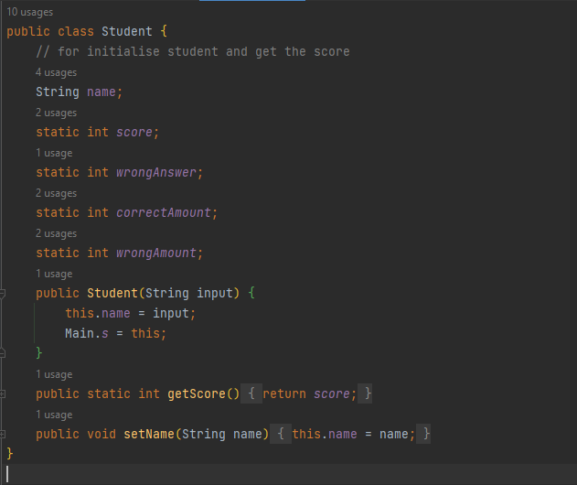

It will store all of the data of the students/examinee, and later those data will be shown when the user/student finish the test.

Every time a test is started the Student object will be created:

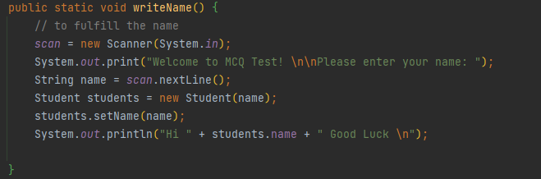

#### The Writer also using Inheritance to make the program

#### 

# Task 5

Step by step that The Writer follow to create this MCQ program:

1. Create a CSV file that will store the MCQ questions on Microsoft Excell, Google Spread Sheet.
2. Create a folder as a place to store CSV files. This folder willl contain all the set of MCQ Test.

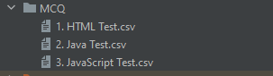

1. Create a new java class called “FileReaderMCQ.java”. This class will perform some of the following tasks:

* Read the CSV file
* Store it in an array
* Print it by starting with the question first and then the options of the answer
* Ask for input from students as answers to the questions and check whether the answers are right or wrong.

public class FileReaderMCQ {  
 BufferedReader reader;  
 public void startTest(String fileName) {  
 try {  
 reader = new BufferedReader(new FileReader(fileName));  
 String output = ""; // for csv file  
 System.*out*.println("\nPlease answer this question..");  
 while ((output = reader.readLine()) != null) {  
 String[] data = output.split(","); //String array for store the data. split = pemisah  
 System.*out*.printf("%s", data[0]); // formatting data directly  
 System.*out*.println();  
 // for displaying option  
 String a = data[1];  
 String b = data[2];  
 String c = data[3];  
 String d = data[4];  
 System.*out*.printf(" A.%s \n B.%s \n C.%s \n D.%s", a, b, c, d, data[5], data[6]);  
 System.*out*.println("\n");  
 // validation option  
 boolean optionTest = true;  
 String getAnswer = null;  
 while (optionTest){  
 Scanner answer = new Scanner(System.*in*);  
 // for displaying answer  
 System.*out*.print("Your answer: ");  
 getAnswer = answer.nextLine();  
 if (Objects.*equals*(getAnswer, "a") || Objects.*equals*(getAnswer, "b") || Objects.*equals*(getAnswer, "c") || Objects.*equals*(getAnswer, "d")){  
 optionTest = false;  
 } else {  
 System.*out*.println("\nYou can only input A,B,C,D\n");

1. Create a new java class called “StartTest.java”. This class will perform some of the following tasks:

* Display the available MCQ set by displaying the CSV file name
* Ask for input from the student/examinee to choose which MCQ set he/she wants to attends
* And calling “read.startTest(path)” to read and display the MCQ set which has been selected by the student/examinee

import java.io.File;  
import java.util.Objects;  
import java.util.Scanner;  
  
public class StartTest extends FileReaderMCQ {  
 //For Choosing the test  
 FileReaderMCQ read = new FileReaderMCQ();  
 Scanner choice;  
 File directoryPath = new File("MCQ");  
 public void chooseTheTest() {  
 showFiles(Objects.*requireNonNull*(directoryPath.listFiles()));  
 choice = new Scanner(System.*in*);  
 String[] f = directoryPath.list();  
 int userChoice = 0;  
 boolean trueChoice = true;  
 while (trueChoice){  
 System.*out*.print("\nInput The Number: ");  
 userChoice = choice.nextInt();  
 System.*out*.println();  
 if (userChoice == 0 || userChoice < 0 || userChoice > Objects.*requireNonNull*(f).length){  
 System.*out*.println("Please Input The Correct Number!");  
 } else {  
 trueChoice = false;  
 }  
 }  
 String path = "MCQ/" + f[userChoice - 1];  
 read.startTest(path);  
 }  
  
 private void showFiles(File[] files) {  
 for (int i = 0; i < files.length; i++){  
 System.*out*.println("Here The MCQ Set: " + files[i].getName().replace(".csv", " ") + "(choose " + (i + 1) + ")");  
 }  
 }  
}

1. Create a class “Student.java”. It will store all of the data of the students/examinee.

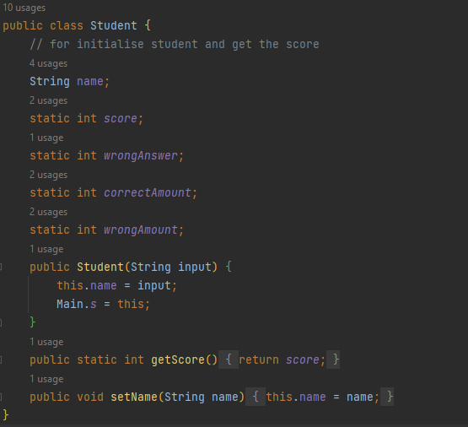

1. And lastly I made logic to run this program sequentially by calling the methods inside Main.java

import java.util.Scanner;  
public class Main {  
 static Scanner *scan*;  
 public static Student *s*;  
 public static void main(String[] args) {  
 // The test will run in here  
 *writeName*();  
 *selectMCQ*();  
 *showResult*();  
 }  
  
 public static void writeName() {  
 // to fulfill the name  
 *scan* = new Scanner(System.*in*);  
 System.*out*.print("Welcome to MCQ Test! \n\nPlease enter your name: ");  
 String name = *scan*.nextLine();  
 Student students = new Student(name);  
 students.setName(name);  
 System.*out*.println("Hi " + students.name + " Good Luck \n");  
  
 }  
 private static void selectMCQ() {  
 StartTest test1 = new StartTest();  
 test1.chooseTheTest();  
 }  
 private static void showResult() {  
 int finalScore = Student.*getScore*();  
 String name = *s*.name;  
 System.*out*.println("Name: " + name + "\nYou answered "+ Student.*correctAmount* + " Questions Right, " + Student.*wrongAmount* + " Question Wrong for a total of 10 Questions " + "\nScore: " + finalScore +"0%");  
 System.*out*.println("\nThank you for attending The Test \nHave a nice day ");  
 }  
}

# Task 6

#### 5 characteristics that The Writer used to create this program:

#### 1. Simple setup

#### It enables me to construct a new java file with all the components quickly. The Writer needs to write an appropriate java class.

#### 2. Deep code analysis

#### It helped The Writer with the code while The Writer was working on this project. It can do refactoring, offer code completion, and instantly discover problems, among other things.

#### 3. Shortcuts on the keyboard

#### One shortcut The Writer often uses is alt+shift+enter (Quick Fix The code). It allows you to fix the code instantly and also gives the option which wants you to fix the code.

#### 4. Run

#### It is capable of running a Java program with just one click.

#### 5. Bug-fixing

#### It assists me in finding issues and reviewing the inner workings of Writer program. Additionally, it enables me to check the functionality and state of the software.

# Task 7

#### The company is required to provide the MCQ system for the situation listed below

#### 1. The system should support multiple MCQ sets. For instance, Basic HTML, Control Structure, and Java

#### 2. The system should show the questions from the selected list after choosing the set.

#### 3. Allow people to respond, and utilize their response to determine the score.

#### The Writer uses Object Oriented Programming Paradigm (OOP) Java with Classes and Methods for making the MCQ Test Program.

#### The institute's instructors created multiple-choice questions and answers using an Excel Spreadsheet. These queries and responses are exported as CSV files (Comma Separated Values). Multiple CSV files with questions for each MCQ test may be found in a folder.

#### Here The Flowchart

#### 

#### The Writer organize development process as follows:

#### 1. The Writer list down a note describing the program's workflow.

#### 2. Choosing an understandable method name

#### 3. Create a class for a certain group for certain processes. Don’t forget to inherit the class like this

#### 

* When facing some issues with the code, the IDE will give a suggest like this

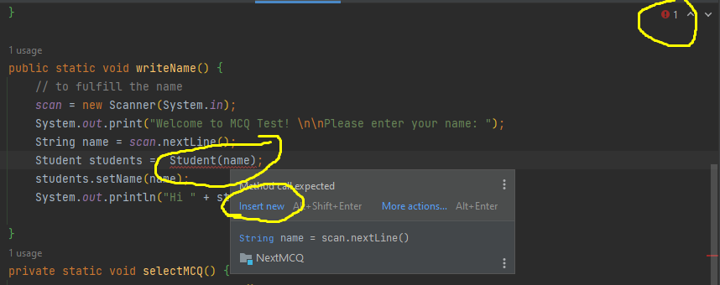

#### When the code change to red color, and the red lamp is showing, we can follow the instruction so the code will fix it like this

#### 

#### The code is fix now

#### 

#### Live template for faster code writing

#### 

# Task 8

IDE saves so much time and this is other benefeit using it :

1. **Syntax highlighting** that helps you be able to read the code and not get lost in between hundreds of lines of code. The IDE uses different colors or formatting for the code, to make it more readable.

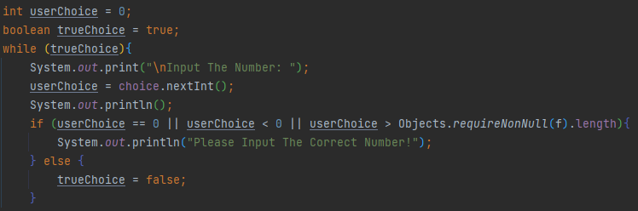

1. **Text autocompletion**, just like the Google search bar does, but for your code. If you forget a keyword, the IDE will give you the best suggestion of what you are looking for.



1. **Refactoring options**, like renaming a file, a function, or a variable; or moving files from one folder to another. This way, you don’t have to update every single reference in the whole project manually.
2. **Importing libraries** in case you remember the code, but not the name of the library. Most likely the IDE already knows what function you’re referring to, it just has to import that library to your project, and you’re all set.



1. **Build, compile, or run** your project just by clicking one button. There’s no need to memorize all those commands and run them one by one from the Console or Terminal.



#### **Pros of Using an IDE**

#### 1. Less time and effort: The entire purpose of an IDE is to make developing faster and easier. Its tools and features are supposed to help you organize resources, prevent mistakes, and provide shortcuts.

#### 2. Enforce project or company standards: Simply by working in the same development environment, a group of programmers will adhere to a standard way of doing things. Standards can be further enforced if the IDE offers predefined templates, or if code libraries are shared between different team members/teams working on the same project.

#### 3. Project management: This can be twofold. First, many IDEs have documentation tools that either automate the entry of developer comments or may force developers to write comments in different areas. Second, simply by having a visual presentation of resources, it is easier to know how an application is laid out as opposed to traversing the file system for arcane files in the file system.

#### **Cons of Using an IDE**

#### 1. Learning curve: IDEs are complicated tools. Maximizing their benefit will require time and patience.

#### 2. A sophisticated IDE may not be a good tool for beginning programmers: If you throw the learning curve of an IDE on top of learning how to program, it can be quite frustrating. Further, features and shortcuts for experienced programmers often hide rucial but mundane details of a language. Details should be noticed when learning a new language. Using an IDE may hamper the learning of a new language.

#### 3. Will not fix bad code, practices, or design: You still need to be proficient and meticulous. An IDE will not eliminate efficiency or performance problems in your application.

# Task 9

#### **Debugging** Usually, the software contains errors and bugs, which are routinely removed. Debugging is the process of fixing a bug in the software.

#### Here The Writer gives the example

#### You must create a breakpoint and right-click on the redline to debug the program. Next, you click the debug menu.

#### 

#### Run program until reach the option test

#### 

#### Check the debug panel. By comparing the data in the debug panel to real code, We can determine whether or not the code is operating as intended.

#### 

#### 

#### 

# Task 10

#### Coding Standrad for class :

#### The class name must be start with uppercase.

#### class Student

#### If the class name is more than two words, the first letter must start with uppercase.

#### class StartTest

#### class FileReader

#### Coding Standard for variable :

#### The name should start with lowercase letter.

#### output data answer choice read

#### If the class name is more than two words, the first letter must start with uppercase.

#### directoryPath trueChoice userChoice startTest showFiles

#### Readability of The Code If you make some code, you must make the function, the method, the variable, and other must easy to understand. Use some general object that everyone know that.

#### 

See this image, the variable, the method using a general name for easy to understand